**Task-5**

**Implement a custom DataFrame transformation function using `apply` and `groupby`**

1. **Task** **Description:**

* To implement a custom DataFrame transformation using both apply and groupby, define a custom function and apply it to each group using apply(). This allows to perform group-specific transformations on the entire DataFrame or selected columns.

1. **Task Output Screenshot:**

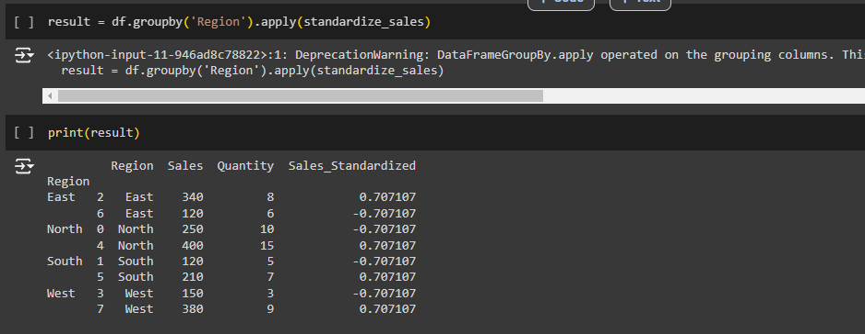

1. **Algorithm Used In Task**

* Create a sample DataFrame.
* Define a custom transformation function.
* Apply the function with groupby() and apply().